**Equations used in link budget calculations**

Wavelength of transmitted signal:

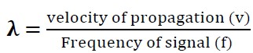

Transmitted Power in dBm (Effective power) (EIRP):



Path Loss (Free space loss):



Power received at the output:

